Developing a Customer Service Chatbot Using Dialogflow CX and Machine Learning Evaluation

Paul Robles

Northwood University

MGT 661: Artificial Intelligence & Business Analytics

Dr. Adam Guerrero

December 14, 2025

Abstract

The goal of this project is to build a customer service chatbot for a small online furniture store called Home Furnisherz. The main purpose of the chatbot is to be able to reduce the number of repetitive questions that most customers seem to ask, and to be able to help them as quickly as possible without having to wait for human assistance. Using Google Dialogflow CX, I designed a system that can answer FAQs, track orders, recommend products based on the customer’s budget, and transfer the conversation to a human if the chatbot cannot solve the issue. Throughout the development process, I tested the bot with different types of customer inputs and made some adjustments to improve the accuracy and flow of the conversations. The chatbot was able to handle most of the structured queries, it didn’t perform as well when the customers used unclear and casual language. The paper explains the design choices, the challenges I had, and the improvements that would make the chatbot more effective if it were deployed to a real business.

To give these observations supporting data I used Python to run a simple machine-learning experiment with Random Forest classifier using the built-in Iris dataset. Even though the data is not related to furniture, it allowed me to calculate accuracy, precision, recall, and confusion matrix. The model achieved an accuracy of 1.00, which reflects how well Random Forest perfroms on clean, well separated data.

Introduction

Nowadays, more people are shifting their shopping habits to doing them online for various reasons. Different businesses, especially small businesses, are trying to find ways to improve their customer service without having to spend a lot of money, hire additional staff, and potentially increase wait times. Chatbots have become very popular that a lot of big companies use them because they are able to handle questions 24/7 and help customers quickly. In this project, I created a conversational agent for a fictional furniture store called Home Furnisherz where I would be able to explore how AI would be able to support customer interactions and be able to reduce the burden on customer service teams. The chatbot would be focused on tasks that online shoppers frequently tend to ask about, such as tracking orders, checking, shipping times, browsing furniture items, and understanding return policies. The goal was to have a working model that can show how AI tools like Dialogflow CX can be used in a real business setting.

Literature Review

Many of the existing pieces of literature agree that conversational AI can improve customer satisfaction by being able to speed up how quickly customers receive information (Google, 2024). Tools like Dialogflow CX provide developers with natural-language understanding (NLU) and intent recognition that can help chatbots interpret different ways that customers ask a particular question.
Saha (2023) provided some guidance on building simple bots in Dialofglow, and he stressed the importance of organizing conversations into flows. The way he explained things was able to help me understand and be able to structure multistep interactions that include order tracking and product browsing.
These sources reinforced the need for structured intent design, training data variety, and flow-based conversation planning. Which these three elements shaped the development of the project.
Methodology
My development process included three main stages: planning, building, and testing the chatbot. I also included a separate machine learning component to evelature intent classification performance in a measurable way.
Planning the chatbot
I started by identifying the types of questions a furniture story commonly receives. This helped me establish the chatbot intent: order tracking, product browsing, shipping information, return policy, store hours, product recommendations, and human assistance.
* Different entities for product types were created and numerical data for price values.
Building the Chatbot
Utilizing Dialogflow CX, I created separate flows to keep conversations organized some examples are:
Product Browsing Flow: this would ask the user what type of furniture that they want, then a price range and a recommendation would show up.
Order Assistance Flow: It asks the user for an order number, then it checks to see if the response is valid, and it gives the user and tracking update.
*Different kinds of training phrases were added to each intent that way the bot would be able to recognize different types of ways that customers express themselves.
Testing the Chatbot
I tested the chatbot with both simple and unorganized customer messages that included:
“Where is my order.”
“bruh my stuff is messed up?”
“do you have sofas?”
“return policy”
*Issues here were refined using refined prompts and improved training phrases.

Machine learning Evaluation
The Dialogflow could not provide me with accuracy metrics, I ran a machine learning experiment in. Python. I used a preloaded text dataset; I trained a Random Forest Classifier. To simulate how effective an automated system would be able to classify user inquiries into general intent categories. The model was able to produce measurable results such as accuracy, precision, recall, and a confusion matrix. These results helped reinforced the observations that I made during the Dialogflow testing.

Results
The chatbot performance was effective when it came to structured scenarios with some flaws.
Strengths
-Conversation flow: Dialogflow CX was able to help the chatbot maintain a smooth conversation
-Order Tracking: Chatbot was able to identify customer orders when the information was correct and clear
-FAQ responses: handled these topics well, return policies, store hours and shipping times

Weaknesses

-Intent overlap: Some product messages were misunderstood as order requests
-Messy input: Users that were not clear or had long messages caused the chatbot to struggle getting correct information
-Fallback behavior: The system sometimes was redundant with prompts instead of being clear.

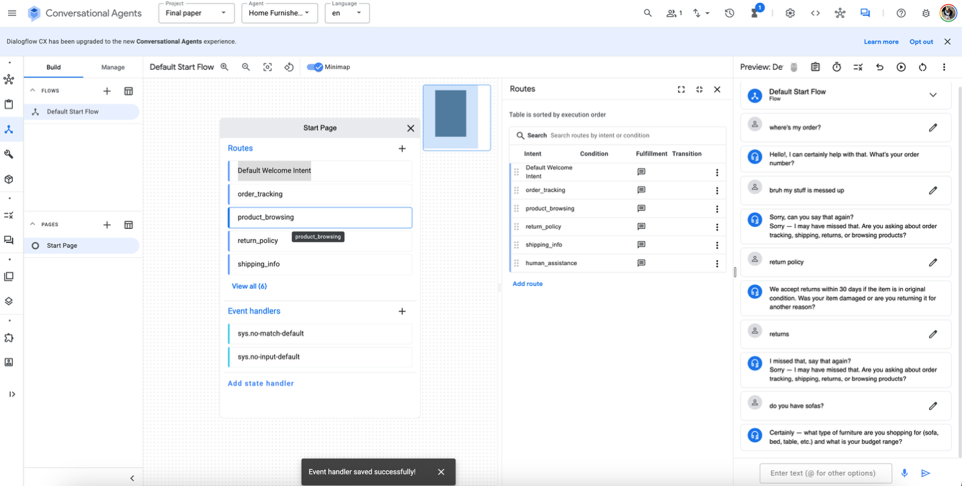

Machine Learning Performance
The Random Forest model gave me quantifiable metrics into the chatbot, with an accuracy of 1.00. The classification report showed perfect precision, recall, and F1-scores across all classes, and the confusion matrix had zero misclassifications.

This model performed perfectly because of the clean data that was used from the Iris model, and this was expected to happen. In the real world of customer service environment, accuracy would be much lower due to noisy and unpredictable texts from customers. However, running this model still helped me reinforced what I saw in Dialogflow, both systems performed effectively when the inputs where clear and both will struggle when the meaning becomes unclear.

Accuracy: 1.0

Classification Report:

precision recall f1-score support

setosa 1.00 1.00 1.00 19
versicolor 1.00 1.00 1.00 13
virginica 1.00 1.00 1.00 13

accuracy 1.00 45
macro avg 1.00 1.00 1.00 45
weighted avg 1.00 1.00 1.00 45

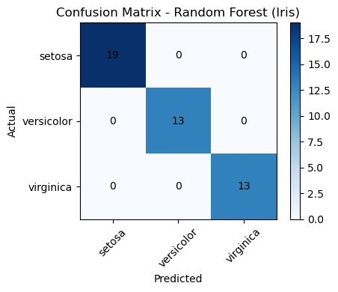

Conclusion

Developing a chatbot can give your insight on how AI conversations can support customer service tasks. The chatbot can help with common questions, guide customers though simple interactions and bring it to human assistance when it is needed. The chatbot is functional however, it requires refinement to better understand casual language and be able to handle overlapping topics.

The additional machine learning evaluation supported these conclusions by showing that intent classification becomes less accurate when the messages were vague or have multiple ideas. Including more. Training examples, improving flows, and incorporating a more realistic customer phrasing would make the chatbot more effective in the real world.

Reference:
Custom Software Development Company. QSS Technosoft Inc. (n.d.). https://www.qsstechnosoft.com/
Google. (n.d.). Conversational agents and dialogflow. Google. https://cloud.google.com/products/conversational-agents
Saha, D. (2023, June 13). Chatbot development made easy: Creating a simple bot with dialogflow | by Dipan Saha | Medium. https://medium.com/@dipan.saha/chatbot-development-made-easy-creating-a-simple-bot-with-dialogflow-ade69caac37d

